Q1.

Include Irvine32.inc

.data

arr1 WORD 1,2,3,4,5,6,7,8,9,10

arr2 WORD 10 DUP(?)

.code

main proc

mov esi,0

mov ecx, LENGTHOF arr1

pushIntoStack:

push arr1[esi \* TYPE arr1]

inc esi

loop pushIntoStack

mov esi,0

mov ecx,LENGTHOF arr2

popFromStack:

pop ax

mov arr2[esi\* TYPE arr2],ax

inc esi

loop popFromStack

mov esi,0

mov ecx,LENGTHOF arr2

printReversedArray:

movzx eax,arr2[esi \* TYPE arr2]

call Writedec

call crlf

inc esi

loop printReversedArray

exit

MAIN ENDP

END MAIN

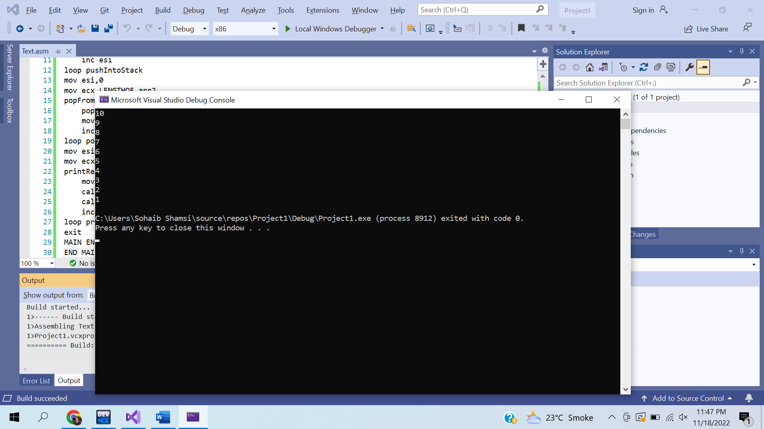

Q2.

Include Irvine32.inc

.data

arr1 DWORD 1,2,3,4,5

arr2 DWORD 1,2,3,4,5

text BYTE "THE SUM OF THE SUM OF THE TWO ARRAYS IS: ",0

SUM DWORD ?

.code

MAIN PROC

call DumDumSum

exit

MAIN ENDP

DumDumSum PROC

call DumSum1

call DumSum2

mov edx,OFFSET text

call WriteString

mov eax,SUM

call WriteDec

ret

DumDumSum ENDP

DumSum1 PROC

mov ecx,LENGTHOF arr1

mov esi,0

Sum1:

mov eax,arr1[esi\* TYPE arr1]

add SUM,eax

inc esi

loop Sum1

ret

DumSum1 ENDP

DumSum2 PROC

mov ecx,LENGTHOF arr2

mov esi,0

Sum2:

mov eax,arr2[esi\* TYPE arr1]

add SUM,eax

inc esi

loop Sum2

ret

DumSum2 ENDP

END MAIN

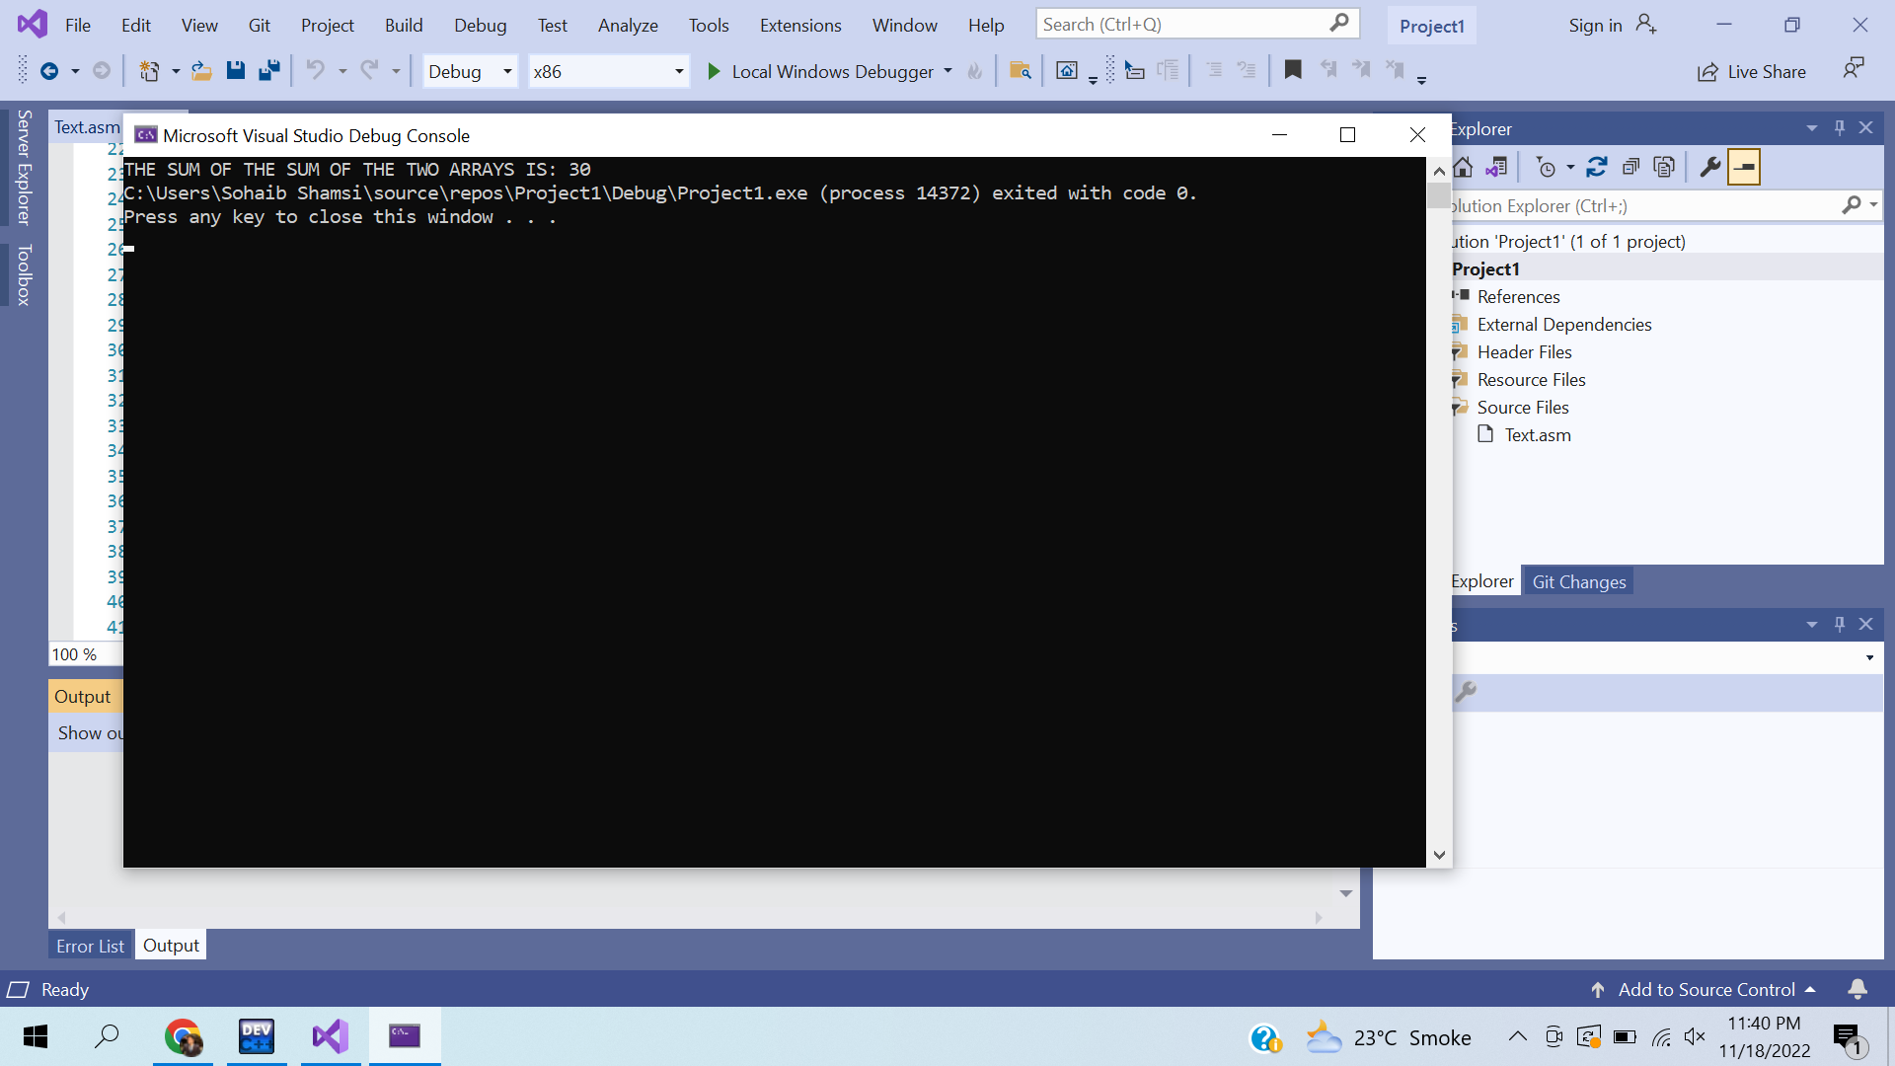

Q3.

Include Irvine32.inc

.data

star BYTE "\*",0

COLUMN DWORD ?

SPACES DWORD ?

SPACE BYTE " ",0

CURRENT DWORD 1

prompt BYTE "Enter the number of columns: ",0

.code

MAIN PROC

mov edx,OFFSET prompt

call WriteString

call ReadInt

mov COLUMN,eax

mov SPACES,eax

call DrawPattern

exit

MAIN ENDP

DrawPattern PROC

mov ecx,COLUMN

XD:

mov ebx,ecx

mov ecx,SPACES

printSpace:

mov edx,OFFSET SPACE

call WriteString

loop PrintSpace

mov ecx,CURRENT

dec SPACES

printStars:

mov edx,OFFSET star

call WriteString

loop printStars

inc CURRENT

mov ecx,ebx

call crlf

loop XD

ret

DrawPattern ENDP

END MAIN

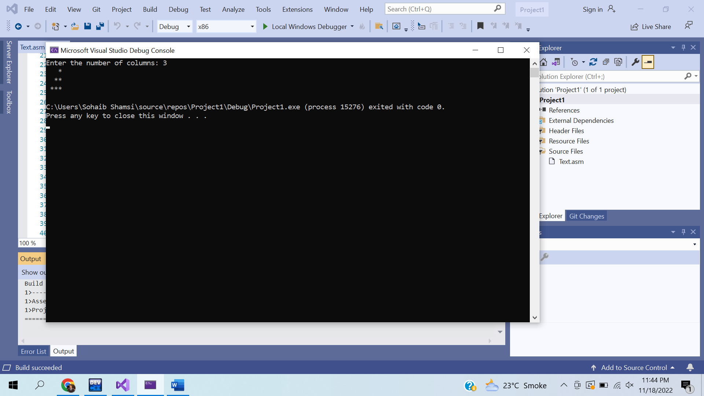

Q4.

Include Irvine32.inc

.data

ALPHABETS BYTE "ABCDEFGHIJKLMNOPQRSTUVWXYZ",0

COLUMN DWORD ?

SPACES DWORD ?

SPACE BYTE " ",0

CURRENT DWORD 1

prompt BYTE "Enter the number of columns: ",0

.code

MAIN PROC

mov edx,OFFSET prompt

call WriteString

call ReadInt

mov COLUMN,eax

mov SPACES,eax

call DrawPattern

exit

MAIN ENDP

DrawPattern PROC

mov ecx,COLUMN

mov esi,0

XD:

mov ebx,ecx

mov ecx,SPACES

printSpace:

mov edx,OFFSET SPACE

call WriteString

loop PrintSpace

mov ecx,CURRENT

dec SPACES

printAlphabets:

mov al,ALPHABETS[esi\* TYPE ALPHABETS]

call WriteChar

inc esi

CMP esi,26

jz resetESI

continueLoop:

loop printAlphabets

jmp proceed

resetESI:

mov esi,0

jmp continueLoop

proceed:

inc CURRENT

mov ecx,ebx

call crlf

loop XD

ret

DrawPattern ENDP

END MAIN

Q5.

TITLE QUESTION # 5

Include Irvine32.inc

.data

prompt BYTE "Enter the value of n: ",0

N DWORD ?

text BYTE "The Sum of the numbers is: ",0

SUM DWORD ?

.code

MAIN PROC

mov edx,OFFSET prompt

call WriteString

call ReadInt

mov N,eax

call sumTheNumbers

mov edx,OFFSET text

call WriteString

mov eax,SUM

call WriteDec

exit

MAIN ENDP

sumTheNumbers PROC

mov ecx,N

mov ebx,1

mov eax,0

mov SUM,eax

addNums:

add eax,ebx

inc ebx

loop addNums

mov SUM,eax

ret

sumTheNumbers ENDP

END MAIN

